NAME: SHIVATHMIKA V
REG NO: 192521028
SUBJECT: csa1204 computer architecture
Q1. Signed Integer Addition Using 2’s Complement
A program performing signed integer addition using 2’s complement produces incorrect results when adding large values such as +120 and +50 in 8-bit representation. The problem can be debugged by examining the binary addition and checking for signed overflow.
Binary Representation
In 8-bit 2’s complement representation:
+120
120 = 01111000
+50
50 = 00110010
Now perform binary addition:
01111000
+ 00110010
----------------
10101010

Debugging Point
For an 8-bit signed number, the valid range is −128 to +127. If the mathematical result goes outside this range, overflow occurs. The uploaded question specifically uses +120 and +50 as the overflow example.
Optimization
Overflow can also be detected using the sign bits:
- Positive + Positive → Negative = overflow
- Negative + Negative → Positive = overflow
Conclusion
The incorrect result is not caused by an addition error. It is caused by 8-bit signed overflow. The program should detect the overflow flag and either report the overflow condition or use a larger integer representation.

Q2. Ripple Carry Adder and Carry Look-Ahead Adder
A processor using a ripple carry adder (RCA) experiences significant delay during arithmetic operations because the carry must propagate sequentially from one bit position to the next.
Problem in Ripple Carry Adder
For each bit, the carry-out depends on the carry-in from the previous bit.
The carry equation is:
Ci+1 = AiBi + (Ai XOR Bi)Ci
For an n-bit ripple carry adder, the carry generated at the least significant bit may have to propagate through all n stages before the final result is available.
For example:
C0 → C1 → C2 → C3 → C4 → ... → Cn
This sequential propagation produces a carry propagation delay.
In a real-time system, this delay can reduce arithmetic performance.
Gi = Ai AND Bi
C1 = G0 + P0C0

C2 = G1 + P1G0 + P1P0C0

C3 = G2 + P2G1 + P2P1G0 + P2P1P0C0
Thus, the carry signals are generated in parallel.
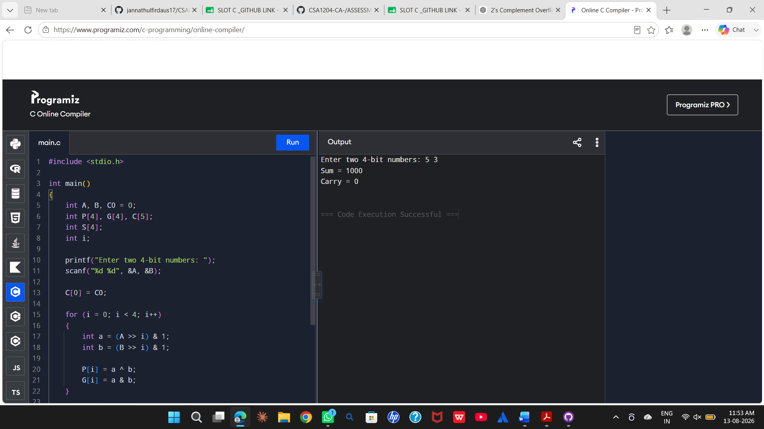

Advantages
Ripple Carry Adder | Carry Look-Ahead Adder
Carry propagates sequentially | Carry is calculated in advance
Higher propagation delay | Lower propagation delay
Simple hardware | More complex hardware
Suitable for low-speed applications | Suitable for high-speed applications
Conclusion
The RCA is slow because of sequential carry propagation. Replacing it with a carry look-ahead adder reduces propagation delay by calculating carries in parallel, making it more suitable for real-time and high-performance processors.

Q3. Debugging Booth’s Algorithm for Signed Multiplication
Booth’s algorithm is used to perform efficient multiplication of signed binary numbers. Incorrect results for negative operands can occur due to errors in bit-pair checking, arithmetic shifting, or sign extension.
Registers Used
Booth’s algorithm uses:
- A – Accumulator
- M – Multiplicand
- Q – Multiplier
- Q-1 – Additional bit
Initially:
A = 0
Q = Multiplier
M = Multiplicand
Q-1 = 0
At every iteration, the pair (Q0, Q-1) is examined.
Bit-Pair Decision Table
Q0 | Q-1 | Operation
0 | 0 | No operation
0 | 1 | A = A + M
1 | 0 | A = A − M
1 | 1 | No operation
After the required addition or subtraction, an arithmetic right shift is performed on the combined register (A, Q, Q-1).
Possible Errors
1. Incorrect bit-pair checking
The algorithm must examine the current Q0 and Q-1 bits correctly. If the pair is incorrectly interpreted, the wrong addition or subtraction operation will be performed.
2. Logical shift instead of arithmetic shift
For negative operands, a logical right shift inserts zero into the most significant bit. This destroys the sign information.
An arithmetic right shift must preserve the sign bit.
For example:
Negative number:
10110010

Arithmetic right shift:
11011001
The leading 1 is retained.
3. Incorrect sign extension
Negative multiplicands must be represented using 2’s complement and sign-extended to the required register width.
4. Incorrect subtraction
For the (10) bit pair:
A = A − M
Subtraction must be performed correctly using 2’s complement arithmetic.
5. Incorrect number of iterations
For n-bit operands, Booth’s algorithm should perform n iterations.
Debugging and Correction
The implementation should follow these steps:
- Initialize A = 0.
- Load the multiplier into Q.
- Set Q-1 = 0.
- Represent negative operands using 2’s complement.
- Examine (Q0, Q-1).
- Perform the appropriate addition or subtraction.
- Perform an arithmetic right shift.
- Preserve the sign bit during shifting.
- Repeat for the required number of iterations.
- Combine A and Q to obtain the final product.
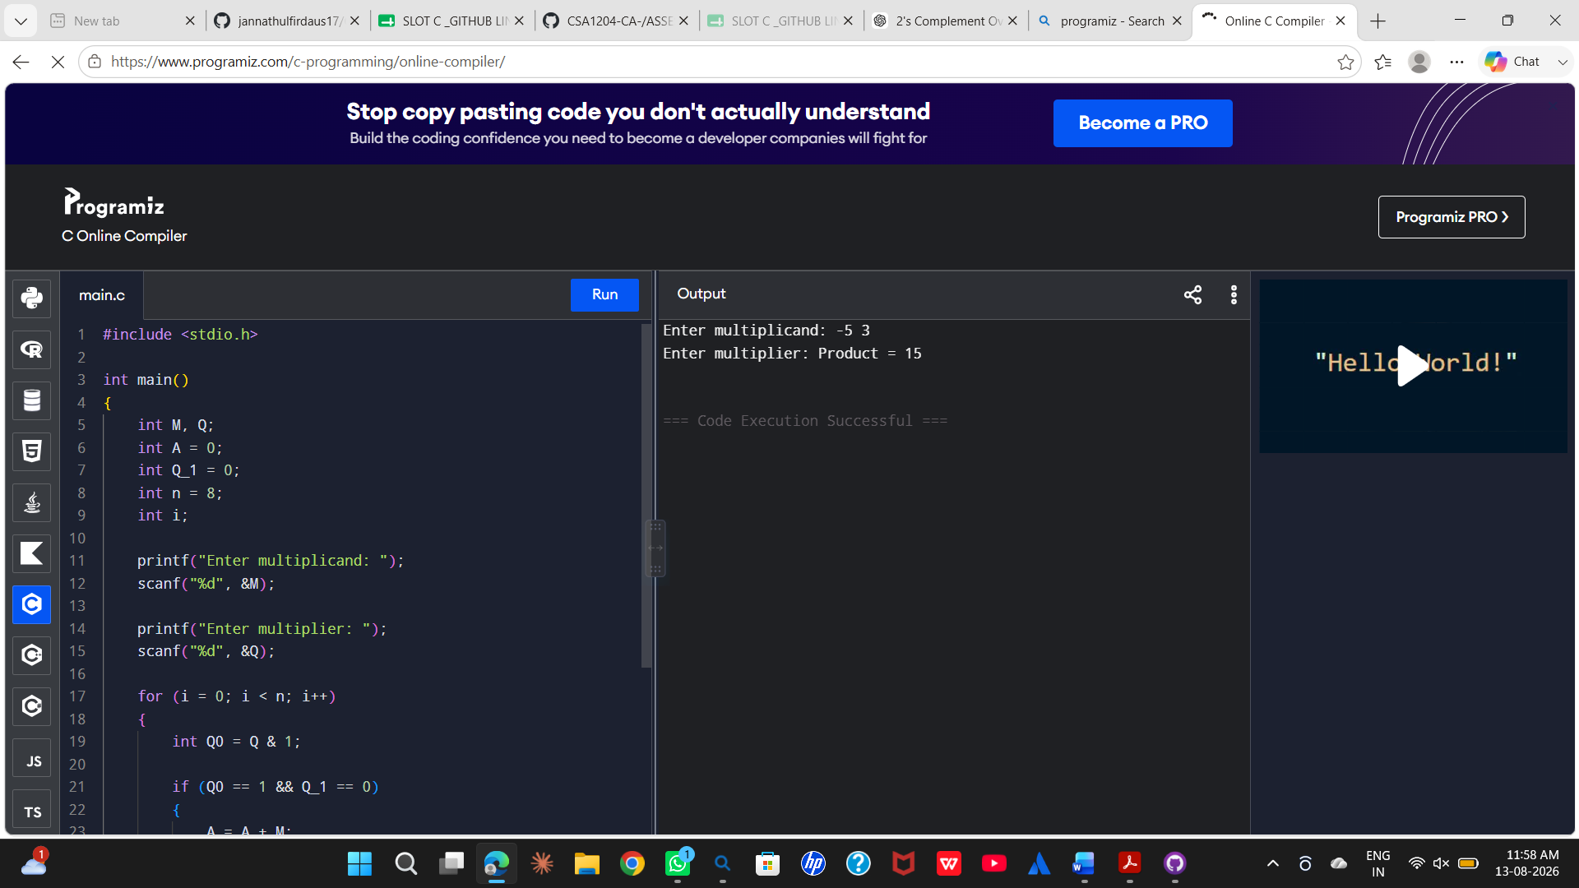
Conclusion
Incorrect signed multiplication in Booth’s algorithm is commonly caused by improper bit-pair checking, incorrect arithmetic shifting, or loss of sign information. Correct 2’s complement representation, sign extension, arithmetic shifting, and iteration control ensure accurate signed multiplication.

Q4. Restoring Division and Non-Restoring Division
The restoring division algorithm can become inefficient because it repeatedly restores the partial remainder whenever a subtraction produces a negative result.
Restoring Division Process
The basic operation is:
A = A − M
where:
- A = partial remainder
- M = divisor
If the result is negative, the divisor must be added back:
If A < 0:
A = A + M
This is called the restoration step.
The workflow is:
Shift
↓
Subtract divisor
↓
Check remainder
↓
Negative?
/ \
Yes No
↓ ↓
Restore Continue
Source of Inefficiency
The main inefficiency occurs when:
A = A − M
produces a negative remainder.
The algorithm then performs:
A = A + M
to restore the previous value.
Therefore, two arithmetic operations may be required for a single unsuccessful subtraction.
Repeated restoration increases execution time.
Optimized Solution: Non-Restoring Division
The non-restoring division algorithm avoids immediately restoring a negative remainder.
Instead, the sign of the current remainder determines the next operation.
If the remainder is positive:
A = 2A − M
If the remainder is negative:
A = 2A + M
Thus, the algorithm does not repeatedly subtract and restore the divisor.
Comparison
Restoring Division | Non-Restoring Division
Negative remainder is restored immediately | Negative remainder is retained temporarily
Requires restoration operations | Avoids repeated restoration
More arithmetic operations | Fewer arithmetic operations
Higher execution time | Improved execution time
Simple implementation | More efficient implementation
At the end of the non-restoring algorithm, if the remainder is negative, a final correction is performed.
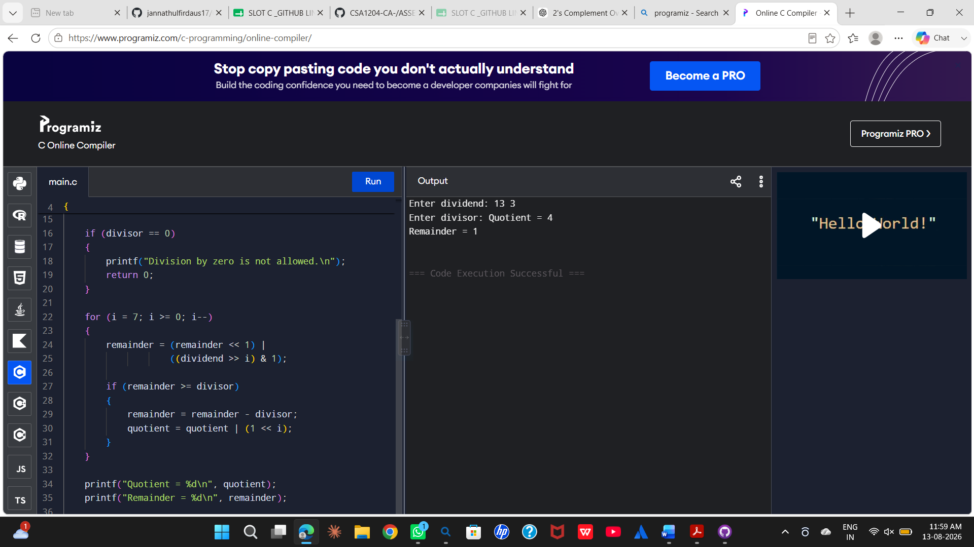
Conclusion
The major inefficiency in restoring division is the repeated restoration of negative partial remainders. Non-restoring division improves performance by avoiding these repeated restoration operations and performing a correction only when necessary.

Q5. IEEE 754 Single-Precision Floating-Point Addition
IEEE 754 single-precision floating-point representation uses 32 bits:
1 bit → Sign
8 bits → Exponent
23 bits → Fraction
The problem occurs when adding a very small number to a very large number. The main causes of inaccurate results are exponent alignment, limited precision, normalization, and rounding.
Exponent Alignment
Before two floating-point numbers are added, their exponents must be made equal.
For example:
Large number = 1.000000 × 10²⁰
Small number = 1.000000 × 10⁰
The smaller number must be shifted to align its exponent with the larger number.
Conceptually:
1.000000 × 10²⁰
0.000000... × 10²⁰
Because single precision has limited significant bits, many bits of the smaller number can be lost during this alignment.
As a result, the smaller number may have little or no effect on the final result.
Normalization
After addition, the result must be normalized into the standard form:
1.xxxxx × 2^E
If the addition produces an extra leading bit, the significand is shifted and the exponent is increased.
If necessary, the significand is shifted in the opposite direction and the exponent is decreased.
Rounding Error
Single precision has limited precision. When more bits are produced than can be stored in the 23-bit fraction field, the extra bits must be rounded.
IEEE 754 uses rounding rules to determine the final stored value.
Therefore, rounding can introduce a small difference between the exact mathematical result and the stored floating-point result.
Example
Consider:
1.0 × 10²⁰ + 1.0
The value 1.0 is extremely small compared with 1.0 × 10²⁰.
During exponent alignment, the significand of 1.0 must be shifted by a very large amount. Its significant bits can fall outside the available precision.
Consequently, the final floating-point result may effectively remain:
≈ 1.0 × 10²⁰
even though mathematically the result is slightly larger.
Optimization Techniques
1. Use double precision
Double precision provides more fraction bits and therefore greater numerical precision.
2. Use appropriate summation algorithms
For repeated floating-point additions, techniques such as compensated summation can reduce accumulated rounding errors.
3. Avoid adding numbers with extremely different magnitudes whenever possible
Values can be grouped or processed in a way that reduces loss of significance.
4. Preserve intermediate precision
Using a higher-precision representation during intermediate calculations can reduce rounding errors.
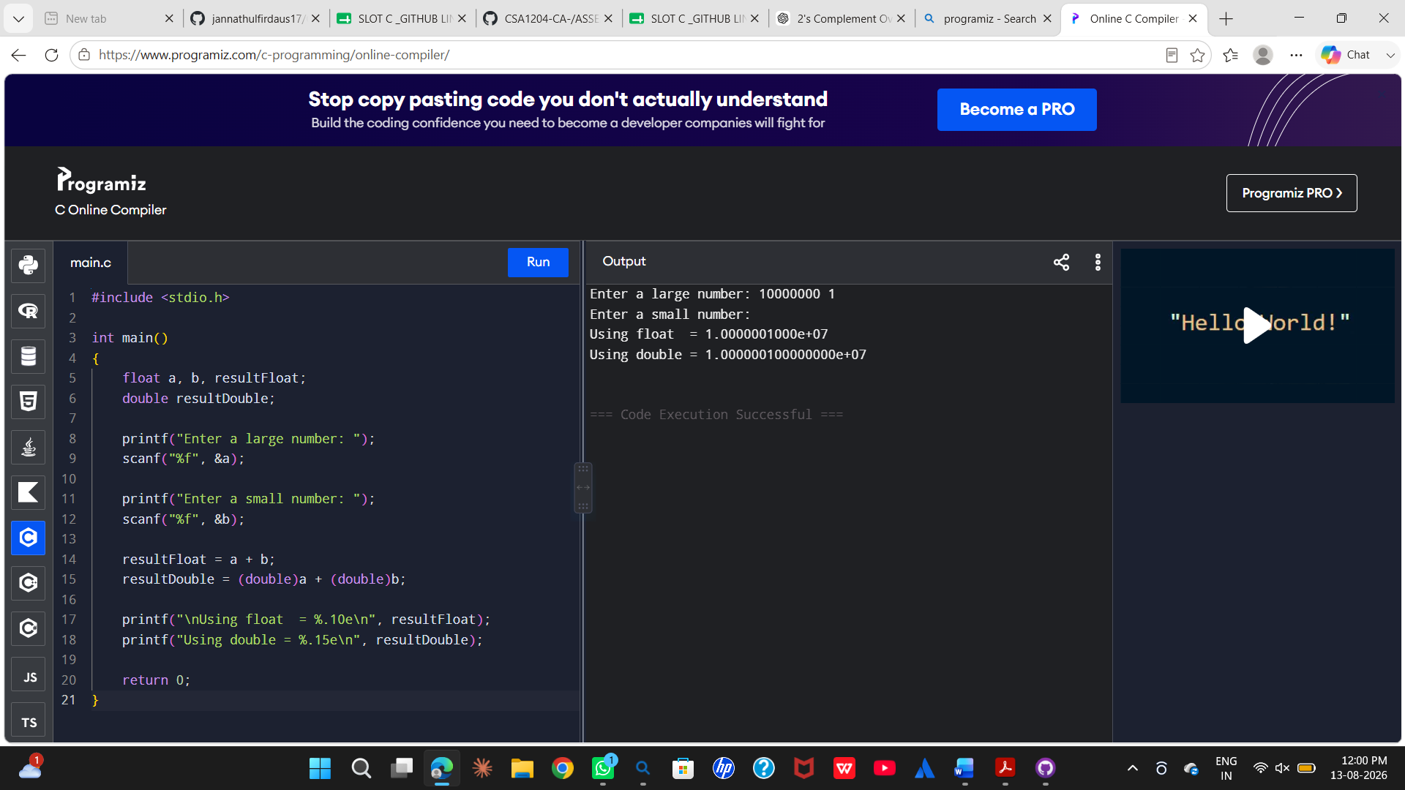
Conclusion
The inaccurate result is primarily caused by the limited precision of IEEE 754 single precision. During exponent alignment, the smaller operand can lose significant bits. Normalization and rounding can introduce additional errors. Using double precision and suitable numerical algorithms can significantly improve the accuracy of floating-point calculations.

